.NET Terrarium 1.2 User Interface Guide

Overview
The purpose of this document is to familiarize you with the user interface of the Terrarium 1.2 client.

Client Window
The screenshot below shows what the user interface for the Terrarium 1.2 client looks like. The window is broken down into several parts, which will be explained in detail later in the document.

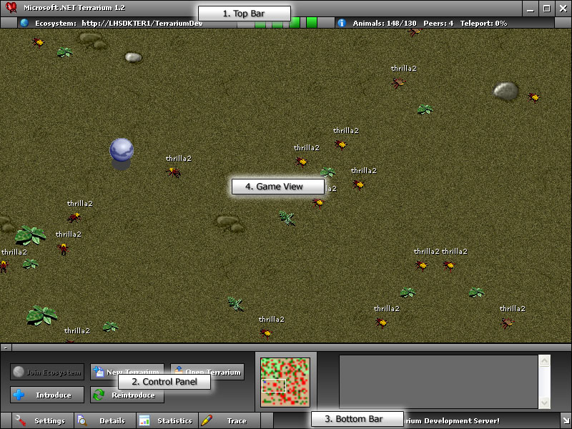

Top Bar
The Top Bar is used primarily for display the current state of the Terrarium client. It also functions as a traditional Windows title bar, providing minimize, maximize and close functionality.
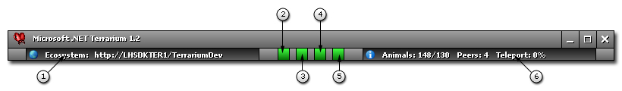

Game Mode
This informs you of what mode the client is running in, Terrarium or Ecosystem, If you are in Ecosystem mode, it also informs you what server you are playing on, or if you are in Terrarium mode, what Terrarium file you are currently using.

Reporting Web Service LED
This LED shows the status of the last Reporting Web Service call to the main Terrarium Server. This call tells the central Terrarium server how many of each type of Animal lives in your Terrarium so that the total number of each type of animal can be tallied at the server.

An LED is a visual indicator of how well that particular function is working. Green means the last call succeeded. Yellow means the call is in progress. Red means the last call failed for some reason. You can hover over an LED to get a tool tip that will provide more information.

Peer to Peer Discovery Web Service LED
This LED shows the status of the last Peer to Peer discovery web service call. This call lets the central Terrarium server know about the existence of this Terrarium in the Ecosystem.

Sent Peer to Peer Request LED
This LED shows the status of the last sent Peer to Peer Request. This request is made when your Terrarium wants to Teleport an animal to another Peer.

Received Peer to Peer Request LED
This LED shows the status of the last received Peer to Peer Request. This request is made when another Peer wants to Teleport an animal into your Terrarium.

Environment Statistics
This provides details about the current state of the client. The Animals area shows you the current and maximum population of your client. The Peers area indicates how many peers are currently in the Ecosystem. The Teleport area shows various teleport statistics. The format looks like the following:

Teleport: <total> (<local>/<remote>/<send failed>/<receive failed>)

Control Panel
The Control Panel is how you interact with the Terrarium world. With it, you will introduce your critters into the world, see a map of your local Terrarium and be informed of critical events that occur.

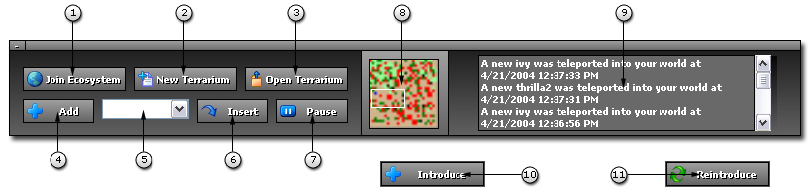

Join Ecosystem Button
This will allow you to join the global Ecosystem if you are currently in Terrarium mode. If you are in Ecosystem mode already, then this button will be disabled.

New Terrarium Button
This will allow you to create a new Terrarium to use for offline purposes. If the client is in Ecosystem mode, then this will switch it to Terrarium mode.

Open Terrarium Button
This button allows you to open an existing Terrarium that was previously saved. If the client is in Ecosystem mode, then this will switch it to Terrarium mode.

Add Button
This enables you to introduce a critter into the Terrarium. A dialog will be displayed that will allow you to pick a critter from the server, or Browse locally to find your critter. This control will not be displayed if the client is in Ecosystem mode.

Critter List Combo Box
This will contain a list of the different critters that have been introduced previously into this Terrarium. You use this in conjunction with the Insert Critter Button to add more instances of a particular critter to the Terrarium. This control will not be displayed if the client is in Ecosystem mode.

Insert Critter Button
This adds a new instance of the critter that is currently selected in the Critter List Combo Box. This control will not be displayed if the client is in Ecosystem mode.

Pause Button
When in Terrarium mode, this allows you to pause the action of the critters. This is very usefully for debugging. Pressing it again will resume the critters.

Minimap
This is a zoomed out, overhead view of the world. Each dot represents a critter, drawn in the marking color the author has chosen. You can use this as a quick way to judge how well your critter is doing. You can also use the Minimap as a quick navigation tool by clicking on it. The game view will center to the area you clicked on. The white frame on the mini map indicates the current location of the game view. The teleporter is represented by a deep blue dot and plants by green dots.

Game Trace
The Game Trace window gives you details about what animals are being teleported into your Terrarium. It does not show animal Trace information. You must use the “Trace” button in the Bottom Bar to view animal trace information.

Introduce Critter Button
Use this button to introduce an animal to the Ecosystem. After you create an animal, and test it out on your own Terrarium, this is the way to introduce it into the Ecosystem. If the client is currently in Terrarium mode, this control will not be visible.

Reintroduce Critter Button
Use this button to reintroduce an animal that has gone extinct (i.e. one that has been killed off from every Terrarium in the Ecosystem). Only extinct animals show up in the Reintroduce Animal window that this button launches. If the client is currently in Terrarium mode, this control will not be visible.

Bottom Bar
The Bottom Bar provides access to the various dialogs you will use to interact with the client. It also contains a status bar and the ability to resize the main client window.

Settings Button
This button will bring up the Game Settings dialog where you can change various settings such as your email address, what server to connect to and the current color scheme used by the client.

Details Button
This button will display the Details dialog. This allows you to view detailed information about the current state of a critter in your Terrarium.

Statistics Button
Pressing this will display the Statistics dialog. This displays statistics such as population, births, deaths and teleport numbers for each species living in your Terrarium.

Trace Button
This button will display the Trace dialog. This dialog displays diagnostic information from the game engine as well as any trace data critters emit via the WriteTrace method.

Ticker Display
This control scrolls through various statistics and information about the Terrarium client and Ecosystem.

Resize Handle
The resize handle allows you to resize the Terrarium client, much like a traditional window.
Game View
The game view is your window into the Terrarium. You can watch the battle of life as it unfolds on your desktop!
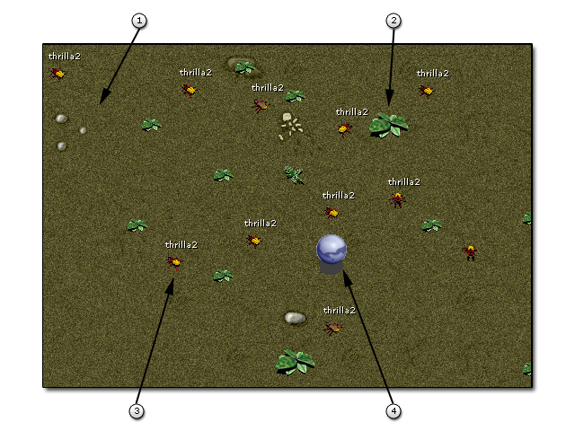

Background
This is the world that the critters in Terrarium walk on. The graphics used will often have random details in it such as rocks, scratches or other items. These do not affect game play and are just cosmetic.

Plant
This is a Plant in the Terrarium. Plants are food for Herbivores. There are several different graphics used for Plants.

Critter
This is a critter. These are what you will program and introduce into the Terrarium. There are several graphics to choose from known as Skins. This one is using the Beetle skin.

Teleporter
The blue ball is known as the Teleporter. If it runs over a Plant or a Critter, it will attempt to send it to another client. If you are in Terrarium mode, or the send fails, you will see it spit the item back out to a random location.

